**THAKUR POLYTECHNIC**

**Diploma in Information Technology**



**IF4I**

**THIRD SEMESTER [2023-2024]**

**GROUP NO -4**

**SUBJECT: Computer Network(22417)**

**TOPIC- Study of FDDI**

1. Manas Londhe 25

2. Rayyan Bhati 04

3. Anas Malkani 27

4. Anant Maurya 31

**Guided by: - Mrs. Isha Shah**



**MAHARASHTRA STATE BOARD OF TECHNICAL EDUCATION**

This is to certify that the following group of students roll no. **4, 25, 27,31** of **4th** semester of Diploma in **INFORMATION TECHNOLOGY** of institute, **THAKUR POLYTECHNIC (Code:0522)** have completed the **Micro Project** satisfactorily in subject **Computer Network (22417)** for the academic year 20**23**–20**24** as prescribed in the curriculum.

Place: MUMBAI Enrollment No: 2205220026

2205220050

2205220054

2205220048

**SEAL OF THE INSTITUTE**

**Subject Teacher Head of Department Principal**

# ACKNOWLEDGEMENT

We feel immense pleasure in submitting this report about **Study of FDDI** While submitting this report, we avail this opportunity to express our gratitude to all those who helped us in completing this task. Heading the list with our own honorable Principal **Dr. S.M. Ganechari** who is the beginner of our inspiration. We owe our deep gratitude and very thankful to our guide **Mrs**. **Isha Shah** and HOD **Mrs. Suwarna Thakre** who has proved to be more than just a mere guide to us. Apart from bringing to us what Can be the joy of successful completion of this project was only possible due to her guidance and co-operation without which this work would never have been completed. Finally, we wish to express our deep sense of respect and gratitude to every staff member who has helped us in many ways and also our parents who have always borne with us in any critical situation and to all others, sparing their time and helping us for completion of this project in whatever way they could. And lastly, we are grateful to each other the members of our group.

***THANK YOU.***

**PROPOSAL**

**MICRO PROJECT PROPOSAL**

1. **AIMS & BENEFITS OF THE PROJECT :-**

* Demonstrate the personal abilities and skills required to produce and present an extended piece of work.
* Engage in personal inquiry, action, and reflection on specific topics and issues.
* Focus on, and demonstrate an understanding of, the areas of interaction.
* Reflect on learning and share knowledge, views, and opinions.

**2.0 Course Outcome Addressed –**

1. Use basic concepts of networking for setting-up computer networks.
2. Setup a computer network for specific requirements.

**3.0 Proposed Methodology** :-

A group discussion was held about the topic. After collecting relevant information, the main work of the project will start. Each member will be doing their allocated work. After completion of the work, every member will be presenting a presentation on the topic with an explanation and finally, the report will be submitted to the respective teacher

**4.0 ACTION PLAN:-**

|  |  |  |  |  |
| --- | --- | --- | --- | --- |
| **SR NO.** | **DETAILS OF THE ACTIVITY** | **PLANNED START DATE** | **PLANNED FINISHED**  **DATE** | **NAME OF RESPONSIBLE TEAM MEMBERS** |
| 1 | INFORMATION  SEARCH |  |  | ALL TEAM  MEMBERS |
| 2 | GROUP  DISCUSSION |  |  | ALL TEAM  MEMBERS |
| 3 | TAKING REFERENCES |  |  | ALL TEAM  MEMBERS |
| 4 | COMPILATION OF REPORTS |  |  | ALL TEAM  MEMBERS |
| 5 | REPORT  SUBMISSION |  |  | ALL TEAM  MEMBERS |

**5.0 RESOURCES REQUIRED:-**

|  |  |  |  |  |
| --- | --- | --- | --- | --- |
| SR.NO | NAME OF RESORCE | SPECIFICATION | QUANTITY | REMARK |
| 1 | Computer System | Windows 11 | 1 | AVAILABLE |
| 2 | Book | Computer Network | 1 | AVAILABLE |
| 3 | Web Browser | Google Chrome | 1 | AVAILABLE |

**6.0 NAME OF TEAM MEMBERS:-**

|  |  |
| --- | --- |
| Roll no of team members | Name of team members |
| 4 | Rayyan Bhati |
| 25 | Manas Londhe |
| 27 | Anas Malkani |
| 31 | Anant Maurya |

**Guided by: - Mrs. Isha Shah**

**REPORT**

**Micro-Project Report**

1. **Rationale:**

The study of Fiber Distributed Data Interface (FDDI) is crucial for several reasons, particularly in the realm of networking and telecommunications. FDDI is a standardized networking technology that provides high-speed data transmission over optical fiber cables.

Below are some key points outlining the rationale for studying FDDI:

* **High-Speed Data Transmission**
* **Reliability and Fault Tolerance**
* **Scalability**
* **Security**

**2.0. Aim/ Benefits of the Micro project:**

* + Demonstrate the personal abilities and skills required to produce and present an extended piece of work.
  + Engage in personal inquiry, action, and reflection on specific topics and issues.
  + Focus on, and demonstrate an understanding of, the areas of interaction.
  + Reflect on learning and share knowledge, views, and opinions.

**3.0. Course Outcome Achieved:**

1. Use basic concepts of networking for setting-up computer networks.
2. Setup a computer network for specific requirements.

**4.0. Literature Review:**

FDDI (Fiber Distributed Data Interface) was a high-performance networking standard introduced in the late 1980s. It offered significant advantages over traditional Ethernet in terms of speed, reliability, and fault tolerance. However, with the emergence of Gigabit Ethernet and other faster technologies, FDDI's use has declined. This review will examine the key features, applications, and limitations of FDDI, exploring its role in the evolution of computer networks.

**5.0. Actual Methodology Followed:**

* A group discussion was held about the topic.
* After collecting relevant information, the main work of the project will start.
* Each member will be doing their allocated work.
* After completion of the work every member will be presenting a presentation on the topic with an explanation and finally the report will be submitted to the respective teacher.

**6.0 RESOURCES REQUIRED:-**

|  |  |  |  |  |
| --- | --- | --- | --- | --- |
| SR.NO | NAME OF RESORCE | SPECIFICATION | QUANTITY | REMARK |
| 1 | Computer System | Windows 11 | 1 | AVAILABLE |
| 2 | Book | Computer Network | 1 | AVAILABLE |
| 3 | Web Browser | Google Chrome | 1 | AVAILABLE |

**7.0. Outputs of the micro project:-**

**What is FDDI & History of FDDI: -**

Fiber Distributed Data Interface (FDDI) is a high-speed networking technology primarily used for connecting local area networks (LANs) using fiber optic cables. Developed in the late 1980s, FDDI was designed to provide high-speed and reliable communication for both voice and data traffic.

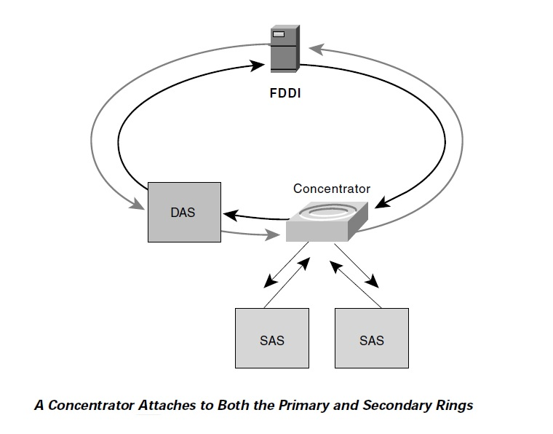

**Uses of FDDI:**

* FDDI is commonly used as a backbone network technology due to its high bandwidth capacity and reliability. It can interconnect multiple LANs or segments within a building or campus network.
* FDDI is suitable for applications requiring high-speed data transmission, such as multimedia streaming, large file transfers, and real-time communication.
* FDDI's dual counter-rotating ring topology provides built-in fault tolerance, making it suitable for mission-critical applications where network downtime must be minimized.

**How the FDDI is used:**

* FDDI is used to build network infrastructures, particularly as backbone networks connecting multiple LANs or segments.
* It is used in enterprise environments where high-speed and reliable communication is essential for business-critical applications.
* FDDI is used in telecommunications networks to provide high-speed data transmission for voice, video, and data services.

**Characteristics of FDDI:**

Following are the few characteristics of FDDI:

1. High speed
2. Dual ring topology
3. Easy scalability
4. Redundancy
5. Reliability

**Advantages of FDDI:-**

* The FDDI supports high data transmission rates up to 100 mbps which also means that FDDI supports high bandwidth.
* The FDDI has a very good fault tolerance because if on of the ring is broken it allows the traffic to continue the flow.
* FDDI is easily scalable.
* It provides good security to unauthorized access to the data transmitted over network

**Disadvantages of FDDI:-**

* Implementing FDDI networks can be expensive due to the cost of fiber optic cabling and networking equipment.
* FDDI networks may require specialized knowledge and expertise to design, configure, and maintain, increasing complexity and operational overhead.
* With the emergence of Ethernet and other high-speed networking technologies, FDDI has seen limited adoption in recent years, particularly in new installations.
* While FDDI's dual-ring topology provides fault tolerance, a failure in the primary ring can still cause disruption if the secondary ring fails to provide backup.

**8.0. Skill Developed/ Learning outcome of the Micro Project:**

In this micro project we learnt about following things :

* What is FDDI?
* Uses of FDDI?
* How it is used?
* Advantages of FDDI
* Disadvantages of FDDI
* Characteristics of FDDI

We have also seen the diagram of FDDI Architecture.

**9.0. Applications of the micro project:-**

FDDI is used mainly in mission critical and high traffic networks where large amounts of data flow need to flow quickly and efficiently. FDDI is used anywhere that utilizes a large network in need of high bandwidth.

**10.0. Conclusion of micro project:**

Overall, FDDI offers a versatile networking solution for various applications that require high-speed, reliable, and fault-tolerant communication. Its deployment across different industries and sectors underscores its importance in supporting critical infrastructure, business operations, and technological advancements.

**REFERENCES:**

1. **https://ipsit.bu.edu/**
2. [**https://telecomposting.wordpress.com/**](https://telecomposting.wordpress.com/)

**Name & roll no. of Team members**

|  |  |
| --- | --- |
| Roll no of team members | Name of team members |
| 4 | Rayyan Bhati |
| 25 | Manas Londhe |
| 27 | Anas Malkani |
| 31 | Anant Maurya |

**Guided by: Mrs. Isha Shah**